Project Report

Name: Clarissa A Indriyani

ID: 2301946171

Due Date: 11-13th November 2019

Table of Contents

Introduction 2

Project Specification 2

Solution Design 3

Discussion 3

Evidence 4

Reference List 5

# Introduction

People say that art is subjective, even the strangest looking art can be sold for a large a mount of money. We live in a society where modern art has taken a fall. In other word is when you see this painting, you’d laugh at it and then you raged about the price that it’s sold for. Just to give you an image, this painting below is sold for 41 million US dollar.

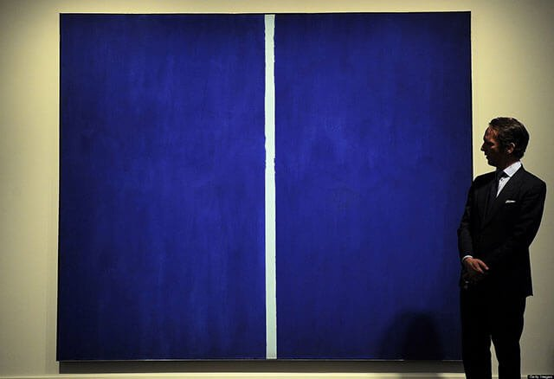

So, this program took the concept and applies it to every art that the user made, no matter how bad your art, this program will appreciate whatever you paint.

# Project Specification

This project is a simple Graphical user interface of Microsoft Paint with a little addition of an interactive game that allows user receive negotiation of prices from the art critic. This program requires Pygame for game display and functionality. The mechanism is quite similar to how a user interact with Microsoft Paint except that it only has the paintbrush functionality. After the user has created their masterpiece, they can click on the publish button, so that a specific amount of money as an offer will appear from the art critic at the bottom of the window/screen.

Requirements for the project:

* Python 3.x
* Pygame

# Solution Design

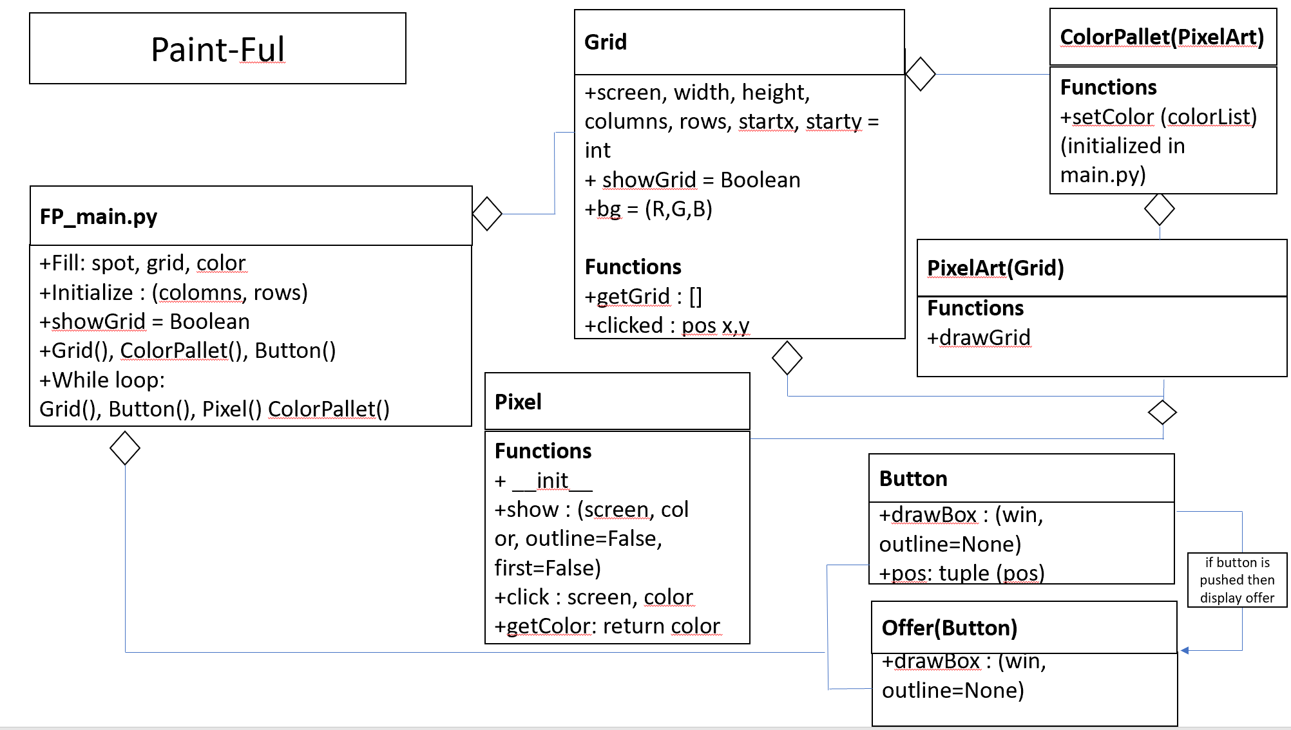

# Discussion

The main function is the FP_main.py where all the variables are initialized and functions inside the class from the other files are called. Grid class in the FP_gridModule.py is the parent class of the PixelArt class which contains 8 arguments which are scree, width, height, columns, rows, startx, starty, showGrid = False, and set the background color to (255,255,255). In the Grid Class there are 2 functions, getGrid which just returns the grid list and clicked which return the position of x and y that the user’s clicked on.

PixelArt class is the child class of the Grid Class which creates the outline or grid for the color pallet. This class contains drawGrid function that draw the outline for the grids. If showGrid is set to True than the grid will be visible, this variable is initialized in the Grid class.

ColorPallet class is derived from the PixelArt class, this function is used to display the colors in the color pallet at the bottom of the screen. Which later on in the FP_main.py, the colors will be assigned which is stored in the Pixel Class.

Pixel class is an independent class which stores the colors that will be appended to the color pallet. This class is used in the ColorPallet Class to add all the appended color to the collor pallet as well as show the pixels.

Lastly, the FP_game_functions.py file adds the twist to the painting program. The Button class creates the button with 6 arguments passed in the FP_main.py file which is color, x (the position in the x axis) ,y (the position of the y axis), width ,height, text=' ' (what strings that should be added in the button). The draw function draws the button with the given arguments and the isOver return the mouse position of the x , y coordinates, in order to detect the MOUSEBUTTONDOWN statement in the FP_main.py file. Next is the Offer class, in this class two rectangle is created to display text which contains the offer. Later on in the FP_main.py file the amount of money is randomize by using randint module.

# Evidence

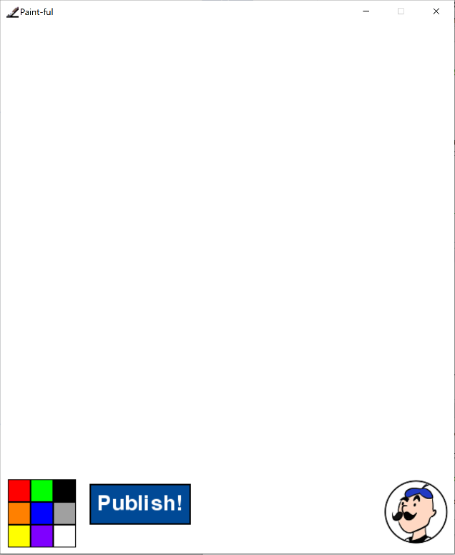

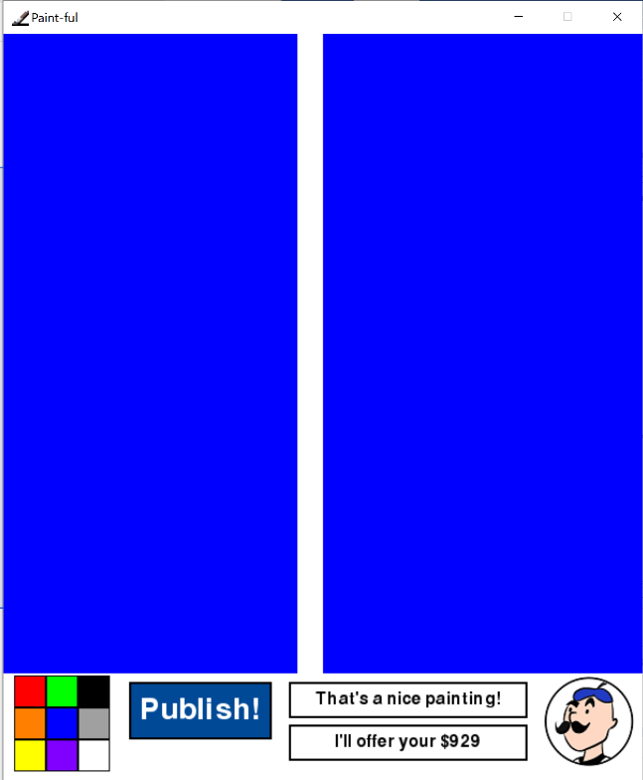

# Reference List

Varma, A. (2016, August 25). 10 Weird-Looking Paintings You Won’t Believe Were Sold for Millions.

*Scoopwhoop.* Retrieved from: <https://www.scoopwhoop.com/Weird-Looking-Paintings-Sold-For-Millions/>